
a
Company
Logotype

Cone Beam Computed Tomography- Report



Porur Dental X-rays & CBCT

Patient Name : Mrs. Janaki | Date of Report : 25.06.2024
Age/ Gender : 74 years/ Female | Region of Interest : CBCT Maxilla
Referring doctor: Dr. Metilda | Indication : Implant assessment
Clinical Notes: Nil
PATIENT INFORMATION

CBCT- Full Skull provided
CBCT – IMAGE DETAILS

RADIOGRAPHIC INTERPRETATION

- Completely missing crown and root portion in relation to 14, 15, 16, 17, 18.
- The maxillary alveolar ridge is present with normal trabecular pattern.

IMPLANT ASSESSMENT

 | 14 region
Sub-Crestal | 6.36
Mid- Crestal | 4.83
Distance between the alveolar ridge and Floor of the Nasal cavity (in mm) | 13.42

 | 15 region | 16 region | 17 region
Sub-Crestal (in mm) | 5.02 | 5.34 | -
Mid- Crestal (in mm) | 6.77 | 6.65 | -
Distance between the alveolar ridge and floor of the maxillary sinus (in mm) | 7.91 | 4.76 | 1.9

RADIOGRAPHIC IMPRESSION

- Partially edentulous maxillary arch.

Kindly correlate with clinical findings


IMAGES FOR REFERENCE

RECONSTRUCTED PANORAMIC VIEW

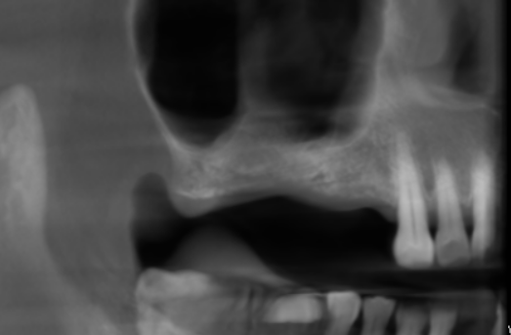

3-DIMENSIONAL VIEW

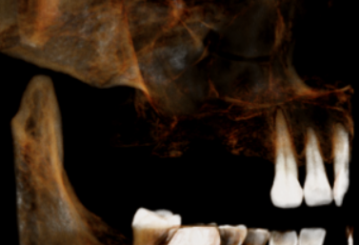

CROSS SECTIONAL VIEW

14 region | 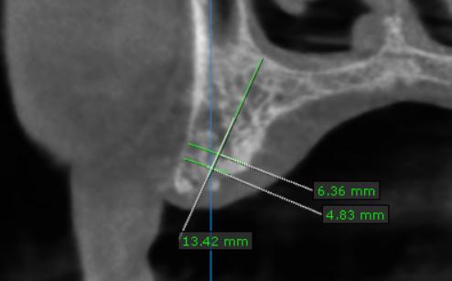
15 region | 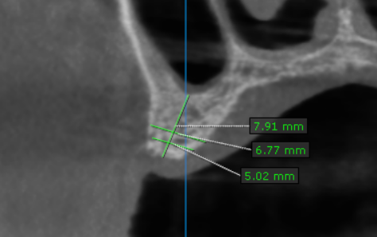
16 region | 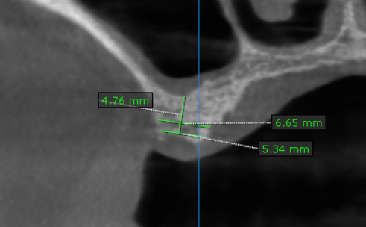
17 region | 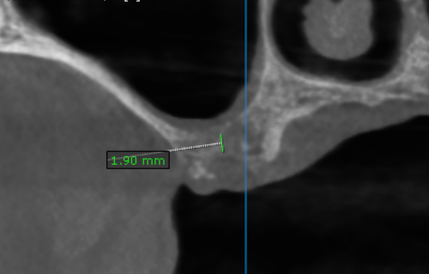

**** End of report ****

